Lab Practical #12:
Study the concept of routing using packet tracer. (Static Routing)
Practical Assignment #12:
- Connect the two different networks based on the calculated IP addresses and subnet using a packet tracer.
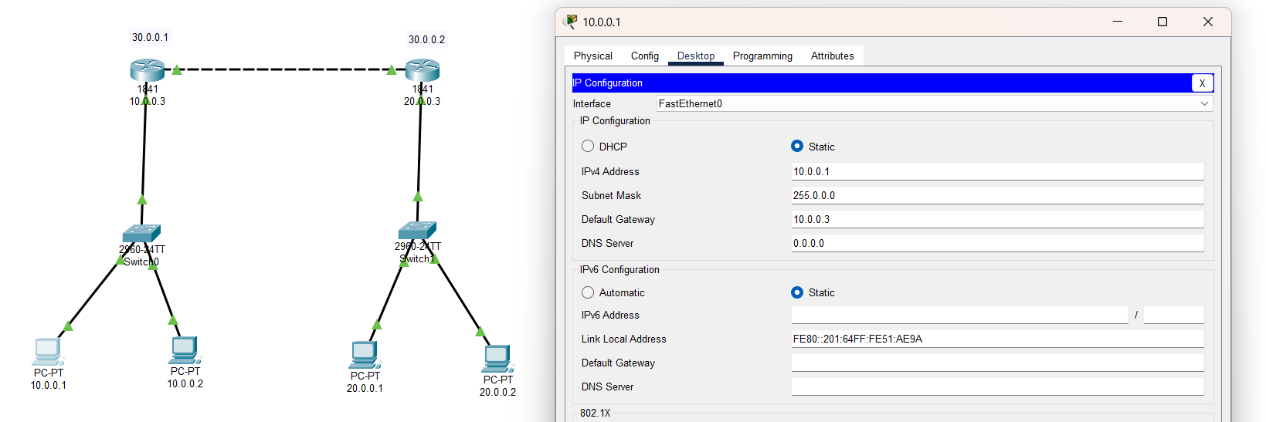

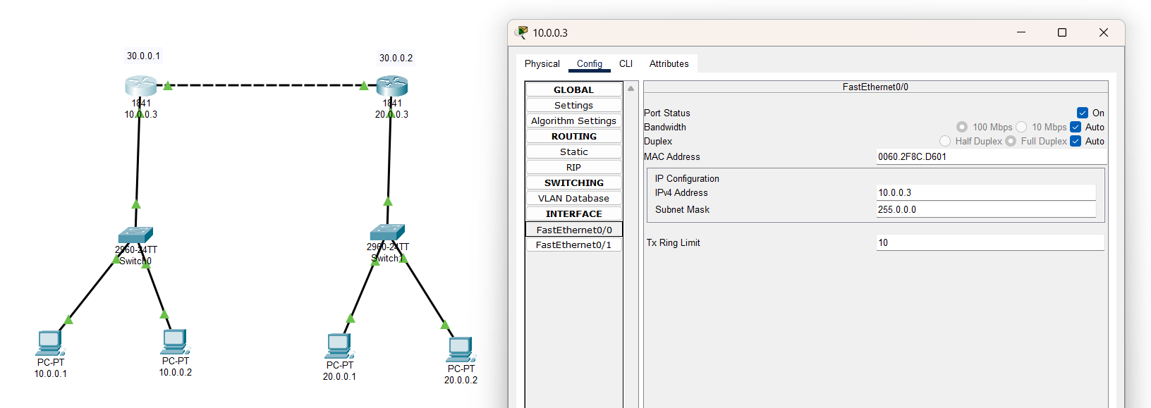

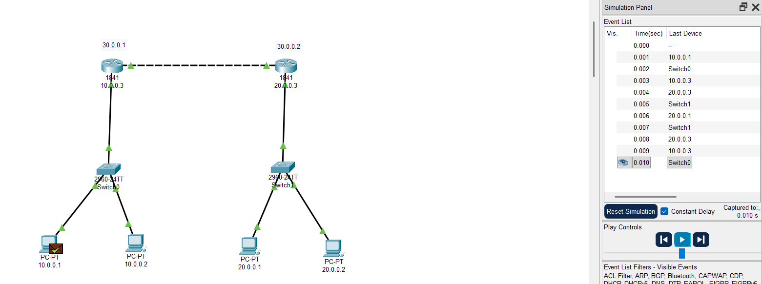
- Connect the three different networks based on the calculated IP addresses and subnet using a packet tracer.
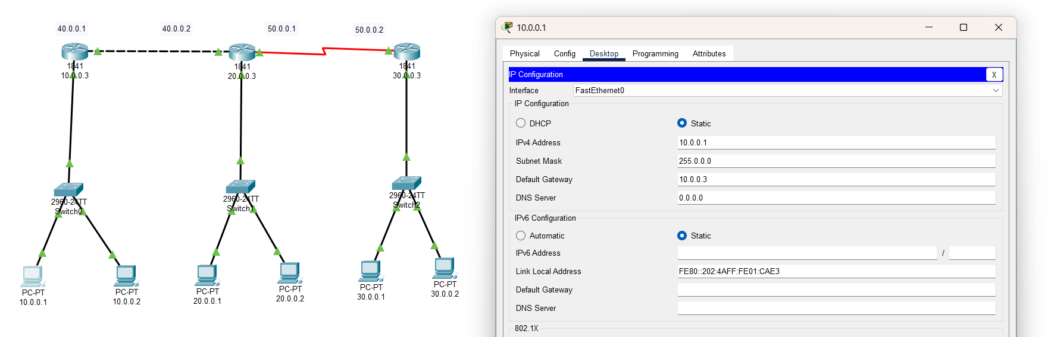

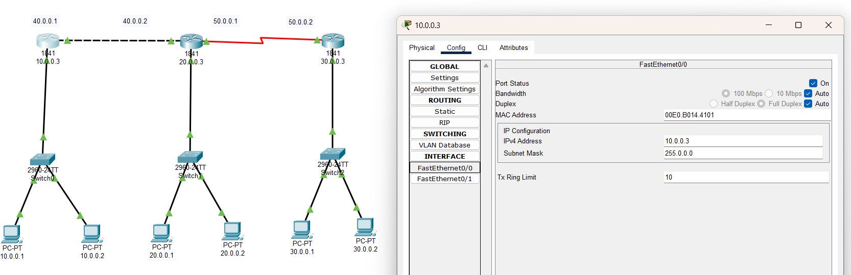

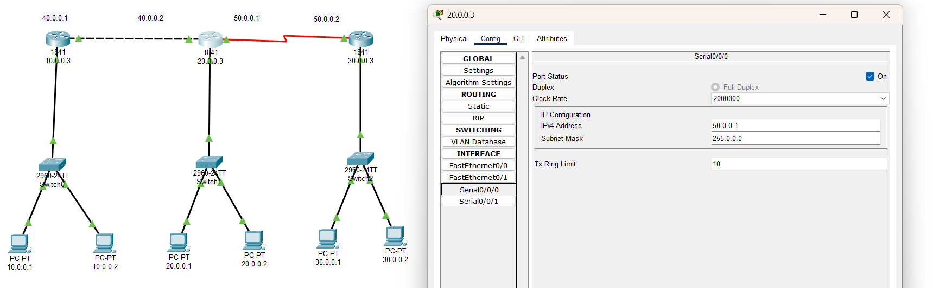

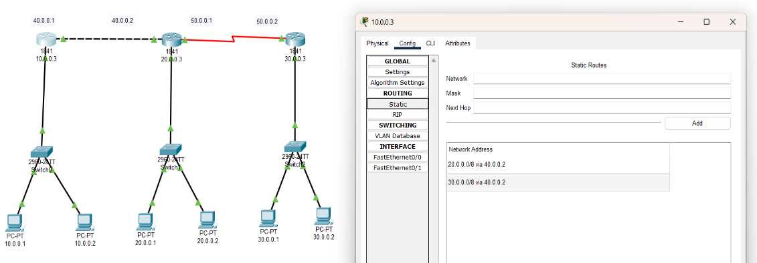

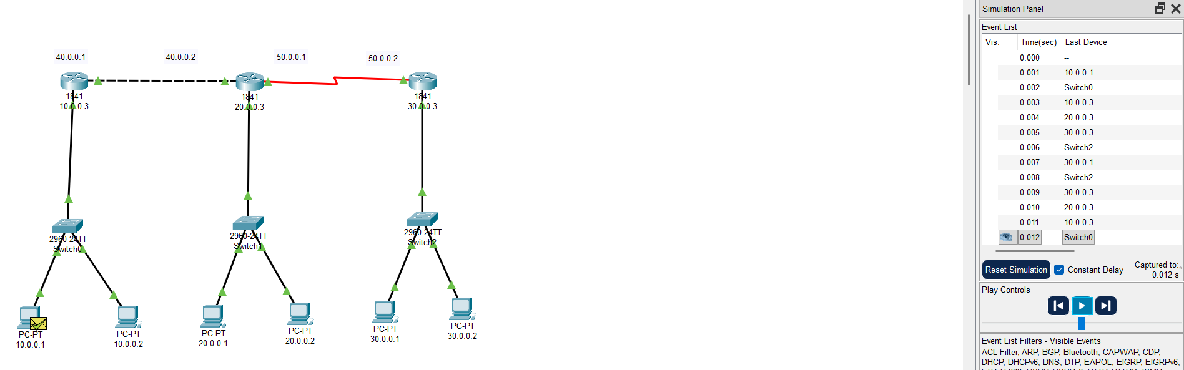

Instructions:
- Static routing screenshot with routing table. (Take two or more different networks)
- Mention IP address of each node and network ID of each network as label.
- Ping command / Packet transfer screenshot between two different network nodes.

